YUVA INTERN TASK 3

Real-World Dataset Analysis: Air Quality in India (2015-2020)
Candidate Detail | Information
Candidate Name | UTSAV KANT JHA
Internship Platform | Yuva Intern
Internship Role | Data Analyst
Submission Date | 16/10/2026

1. Introduction and Objective
Air quality directly affects public health. This project analyzes daily air-quality readings from Indian cities to understand which cities are most polluted, how pollution changes across years and seasons, which pollutants drive the Air Quality Index (AQI), and how the 2020 lockdown affected air quality.
Objectives
- Select a reliable real-world dataset and understand its context and variables.
- Explore its structure, data types, distributions, missing values and duplicates.
- Clean and preprocess the data with justified decisions.
- Perform EDA using Pandas, NumPy and statistical techniques.
- Build meaningful visualizations.
- Present insights, conclusions and recommendations.

2. Dataset Description
- Name: Air Quality Data in India (2015-2020), file city_day.csv
- Source: Kaggle (author: rohanrao). The original data is published by the Central Pollution Control Board (CPCB), Government of India.
- Coverage: 26 cities, daily readings, 1 January 2015 to 1 July 2020
- Size: 29,531 rows and 16 columns
Column | Meaning
City, Date | City name and observation date
PM2.5, PM10 | Fine and coarse particulate matter
NO, NO2, NOx | Nitrogen oxides
NH3 | Ammonia
CO | Carbon monoxide
SO2 | Sulphur dioxide
O3 | Ozone
Benzene, Toluene, Xylene | Volatile organic compounds
AQI | Air Quality Index (higher means worse air)
AQI_Bucket | Category: Good, Satisfactory, Moderate, Poor, Very Poor, Severe

3. Setup
import pandas as pd
import numpy as np
import matplotlib.pyplot as plt
import seaborn as sns
import warnings
warnings.filterwarnings('ignore')
sns.set_style('whitegrid')
plt.rcParams['figure.figsize'] = (10, 5)
df = pd.read_csv('city_day.csv')

4. Data Exploration
4.1 Shape and first rows
print('Shape:', df.shape)
display(df.head())

Output:
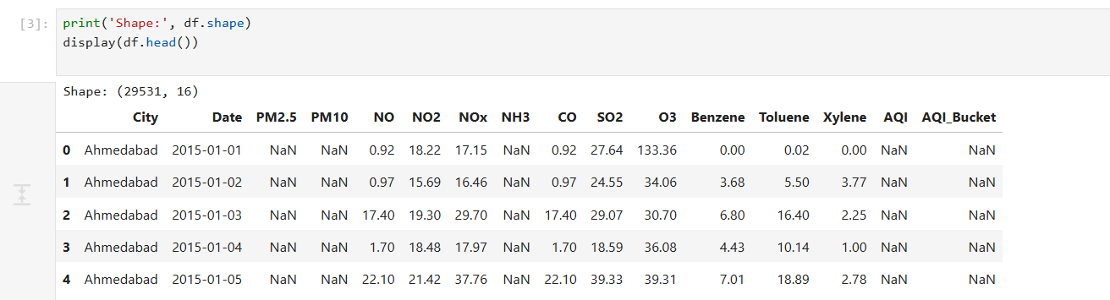
4.2 Data types and summary statistics
df.info()
display(df.describe().T)

Output:
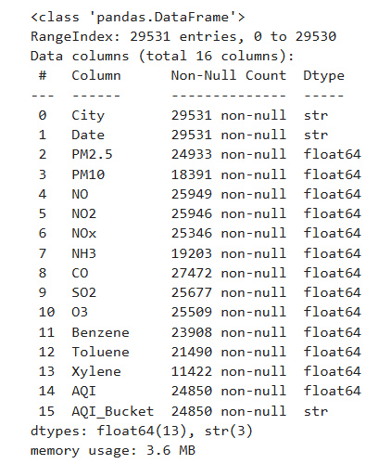
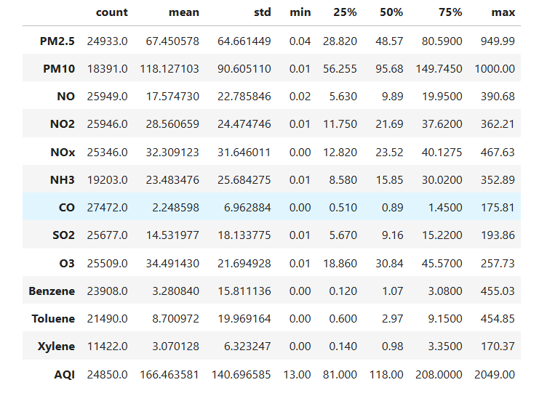
4.3 Missing values
missing = df.isnull().sum()
missing_pct = (missing / len(df) * 100).round(1)
display(pd.DataFrame({'missing': missing, 'percent': missing_pct}).sort_values('percent', ascending=False))

Output:
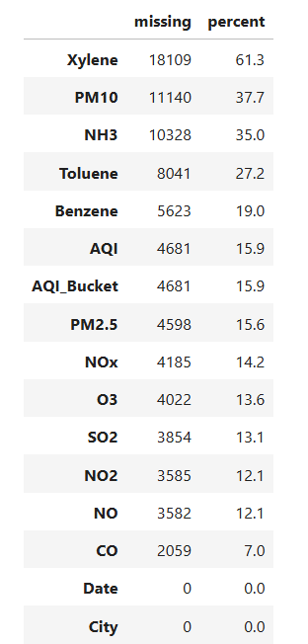

4.4 Duplicates, cities and date range
print('Duplicate rows:', df.duplicated().sum())
print('Duplicate City+Date:', df.duplicated(['City', 'Date']).sum())
print('Number of cities:', df['City'].nunique())
print('Date range:', df['Date'].min(), 'to', df['Date'].max())
print()
print(df['City'].value_counts())

Output:
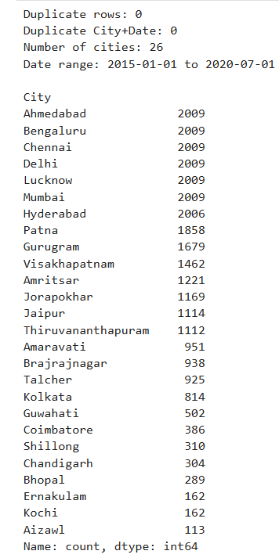

4.5 Data coverage per city
coverage = df.groupby('City')['Date'].agg(['min', 'max', 'count'])
display(coverage)

Output:
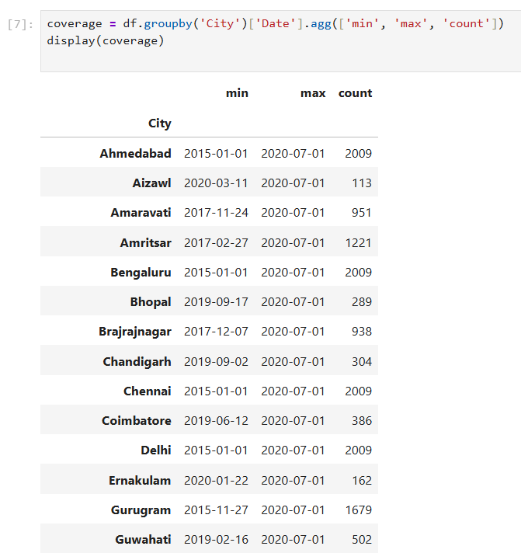
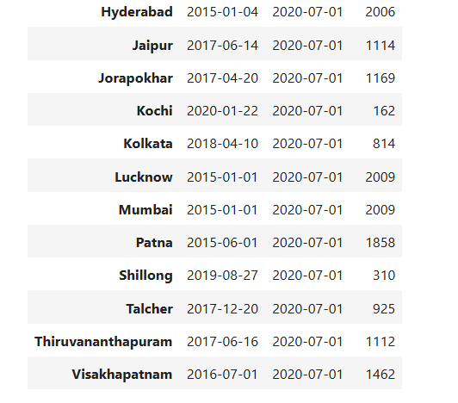
Your observation: The dataset has no duplicate rows and no duplicate City+Date records. Xylene has the most missing values (61.3%), followed by PM10 (37.7%) and NH3 (35.0%). Data coverage differs a lot between cities: Delhi, Ahmedabad, Bengaluru, Chennai, Lucknow and Mumbai have 2,009 days each from January 2015, while Aizawl has only 113 days (from March 2020) and Kochi and Ernakulam only 162 days.

5. Data Cleaning and Preprocessing
5.1 Fix the Date data type
The Date column is read as text. It is converted to datetime so that year, month and season can be extracted.
df['Date'] = pd.to_datetime(df['Date'])
print(df['Date'].dtype)

Output:
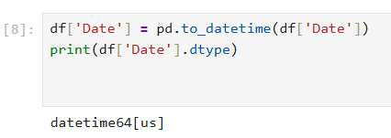
5.2 Drop the Xylene column
Xylene has about 61% missing values. Filling that many values would mean inventing most of the column, so the column is dropped.
df = df.drop(columns=['Xylene'])
print(df.shape)

Output:
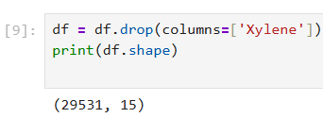
5.3 Drop rows where AQI is missing
AQI is the main target variable and is calculated officially by CPCB from the pollutant readings. Filling it with an estimate would create artificial values, so rows with missing AQI are removed.
rows_before = len(df)
print('AQI_Bucket missing where AQI missing:', df[df['AQI'].isnull()]['AQI_Bucket'].isnull().all())
df = df.dropna(subset=['AQI']).copy()
print('Rows before:', rows_before, '| Rows after:', len(df))

Output:
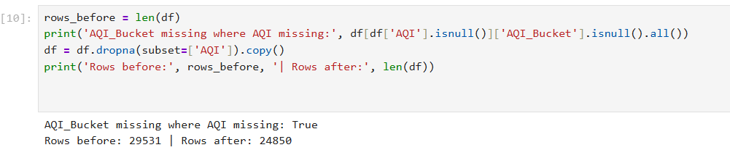
5.4 Fill missing pollutant values with the city-wise median
The median is used instead of the mean because pollution data is right-skewed with extreme values. Each city is filled with its own median because pollution levels differ a lot between cities. If a city has no value at all for a pollutant, the overall median is used.
pollutants = ['PM2.5', 'PM10', 'NO', 'NO2', 'NOx', 'NH3', 'CO', 'SO2', 'O3', 'Benzene', 'Toluene']
for col in pollutants:
df[col] = df.groupby('City')[col].transform(lambda s: s.fillna(s.median()))
df[col] = df[col].fillna(df[col].median())
print(df.isnull().sum())

Output:
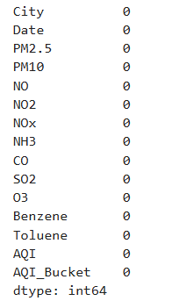
5.5 Check duplicates and consistency
print('Duplicate rows:', df.duplicated().sum())
print(sorted(df['City'].unique()))
print(df['AQI_Bucket'].unique())
print('Negative values:', (df[pollutants + ['AQI']] < 0).sum().sum())

Output:
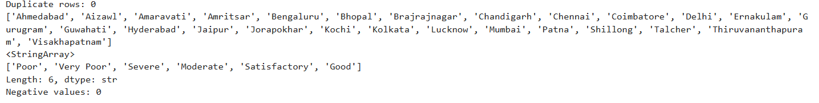
5.6 Create new columns: Year, Month and Season
Seasons follow the Indian pattern: Winter (Dec-Feb), Summer (Mar-May), Monsoon (Jun-Sep), Post-Monsoon (Oct-Nov).
df['Year'] = df['Date'].dt.year
df['Month'] = df['Date'].dt.month
def get_season(m):
if m in [12, 1, 2]:
return 'Winter'
elif m in [3, 4, 5]:
return 'Summer'
elif m in [6, 7, 8, 9]:
return 'Monsoon'
return 'Post-Monsoon'
df['Season'] = df['Month'].apply(get_season)
display(df[['City', 'Date', 'AQI', 'AQI_Bucket', 'Year', 'Month', 'Season']].head())

Output:
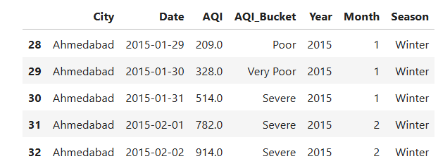
5.7 Detect outliers (IQR method)
def iqr_outliers(col):
q1, q3 = df[col].quantile([0.25, 0.75])
iqr = q3 - q1
low, high = q1 - 1.5 * iqr, q3 + 1.5 * iqr
return ((df[col] < low) | (df[col] > high)).sum()
outliers = pd.Series({c: iqr_outliers(c) for c in ['PM2.5', 'PM10', 'CO', 'AQI']})
print(outliers)
fig, axes = plt.subplots(1, 3, figsize=(15, 4))
sns.boxplot(y=df['PM2.5'], ax=axes[0], color='skyblue')
sns.boxplot(y=df['PM10'], ax=axes[1], color='lightgreen')
sns.boxplot(y=df['AQI'], ax=axes[2], color='salmon')
axes[0].set_title('PM2.5')
axes[1].set_title('PM10')
axes[2].set_title('AQI')
plt.tight_layout()
plt.show()

Output:
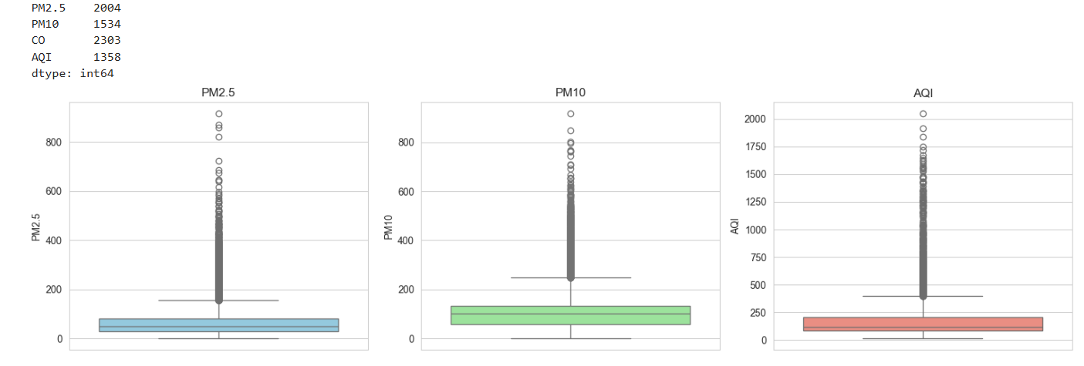
Decision on outliers: The outliers are kept. Very high readings are real pollution events (for example winter smog in North India) and not data-entry errors, so removing them would hide the exact problem this project studies. Because of these extreme values, the median is reported along with the mean.
Ahmedabad's AQI also contains values above 1,000, which are outside the official 0-500 AQI scale and may be data errors. They are kept but noted in the limitations.
5.8 Save the cleaned dataset
print('Final shape:', df.shape)
print('Total missing values:', df.isnull().sum().sum())
df.to_csv('city_day_clean.csv', index=False)

Output:
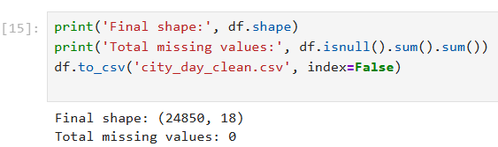

6. Exploratory Data Analysis (EDA)
6.1 Descriptive statistics using NumPy
aqi = df['AQI'].values
print('Mean AQI :', round(np.mean(aqi), 2))
print('Median AQI :', round(np.median(aqi), 2))
print('Std Dev :', round(np.std(aqi), 2))
print('90th pct :', round(np.percentile(aqi, 90), 2))
print('Max AQI :', np.max(aqi))
print('Skewness :', round(df['AQI'].skew(), 2))

Output:
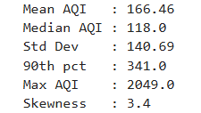
Your observation: Mean AQI (166.46) is higher than the median (118.0) and skewness is 3.40, so the distribution is strongly right-skewed: a few extremely polluted days pull the average up. 90% of days have AQI below 341, but the maximum reaches 2,049.
6.2 Most and least polluted cities (Bar chart)
city_aqi = df.groupby('City')['AQI'].mean().sort_values(ascending=False)
print('Least polluted cities:')
print(city_aqi.tail(5).round(1))
city_aqi.head(10).plot(kind='bar', color='firebrick')
plt.title('Top 10 Cities by Average AQI')
plt.xlabel('City')
plt.ylabel('Average AQI')
plt.xticks(rotation=45)
plt.tight_layout()
plt.show()

Output:
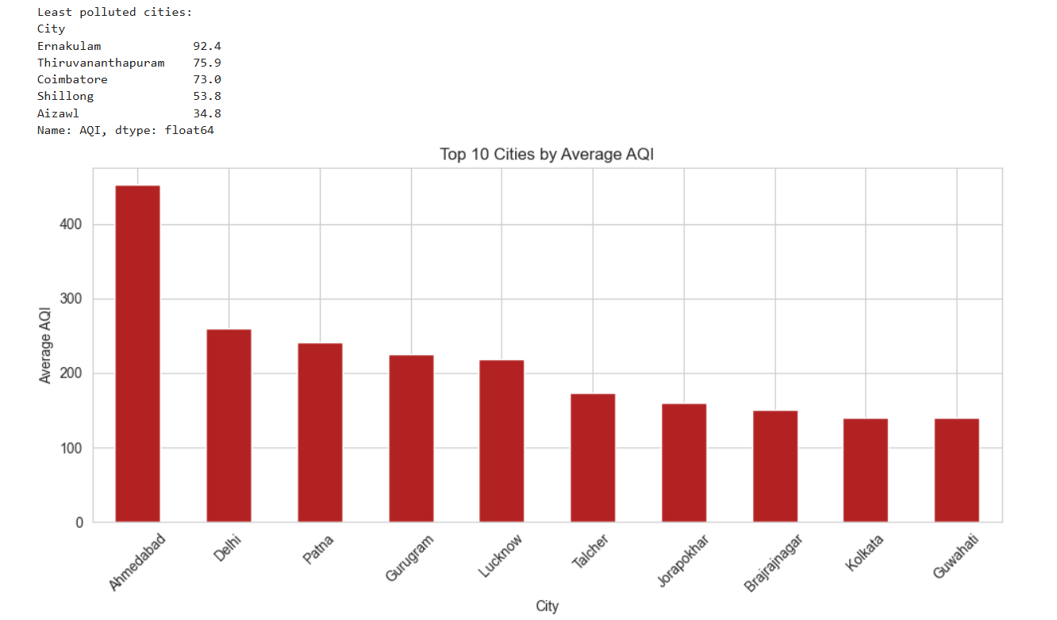
Observation: Ahmedabad has the highest average AQI (452.1), followed by Delhi (259.5), Patna (240.8), Gurugram (225.1) and Lucknow (218.0). Aizawl (34.8) and Shillong (53.8) are the cleanest, but they have only about 110 and 310 days of data, so they are not directly comparable. Ahmedabad's value is unusually high, as 412 of its readings are above 500, which suggests possible data issues.

6.3 Distribution of AQI (Histogram)
sns.histplot(df['AQI'], bins=50, kde=True, color='teal')
plt.title('Distribution of AQI')
plt.xlabel('AQI')
plt.ylabel('Number of days')
plt.show()

Output:
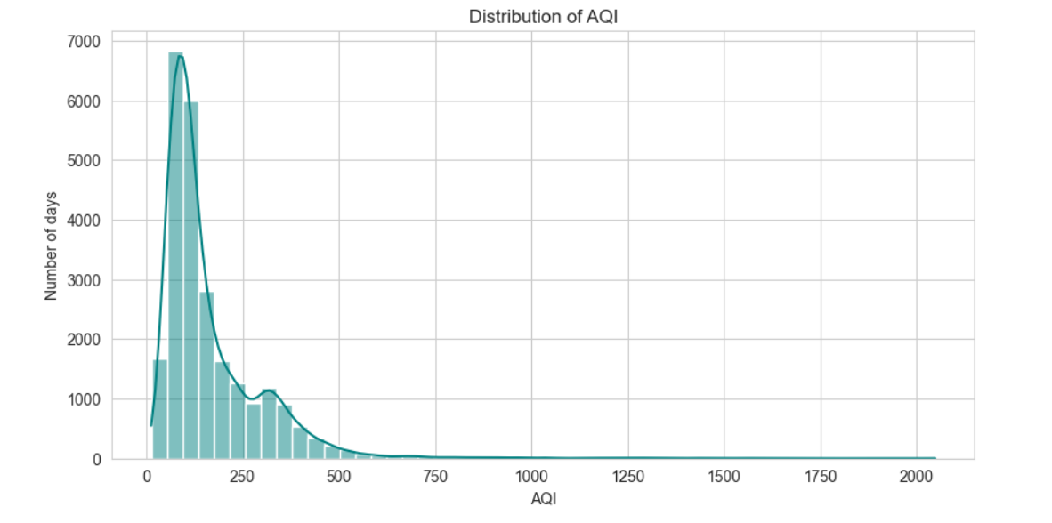
6.4 Number of days in each AQI category
order = ['Good', 'Satisfactory', 'Moderate', 'Poor', 'Very Poor', 'Severe']
colors = ['green', 'yellowgreen', 'gold', 'orange', 'red', 'darkred']
sns.countplot(data=df, x='AQI_Bucket', order=order, palette=colors)
plt.title('Days per AQI Category')
plt.xlabel('AQI Category')
plt.ylabel('Number of days')
plt.show()

Output:
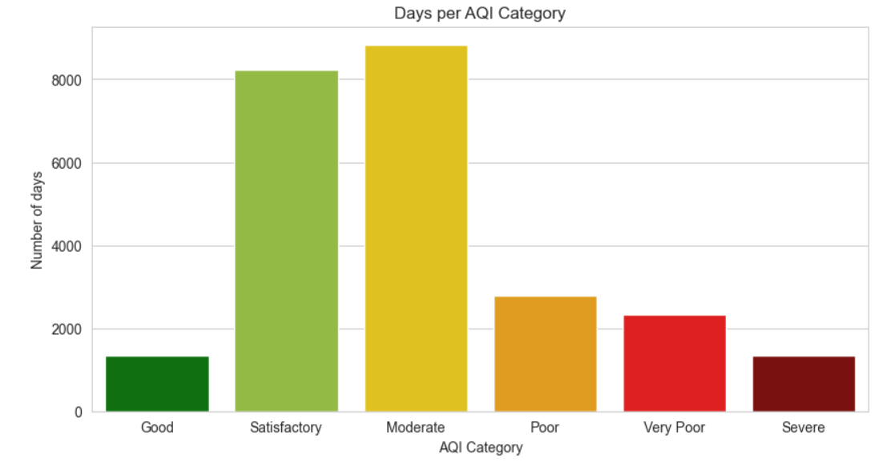

Observation: About 26.0% of days (6,456 of 24,850) fall in the Poor, Very Poor or Severe categories. Moderate (8,829) and Satisfactory (8,224) are the most common, and Severe days number 1,338 (5.4%).

6.5 Yearly AQI trend (Line chart)
Only the six cities that have data from 2015 are used, so that the comparison across years is fair. Note that 2020 has data only up to 1 July.
core = ['Ahmedabad', 'Bengaluru', 'Chennai', 'Delhi', 'Lucknow', 'Mumbai']
yearly = df[df['City'].isin(core)].groupby(['Year', 'City'])['AQI'].mean().unstack()
yearly.plot(marker='o', figsize=(10, 5))
plt.title('Average AQI by Year (six cities with the longest coverage)'
plt.xlabel('Year')
plt.ylabel('Average AQI')
plt.legend(title='City')
plt.show()

Output:
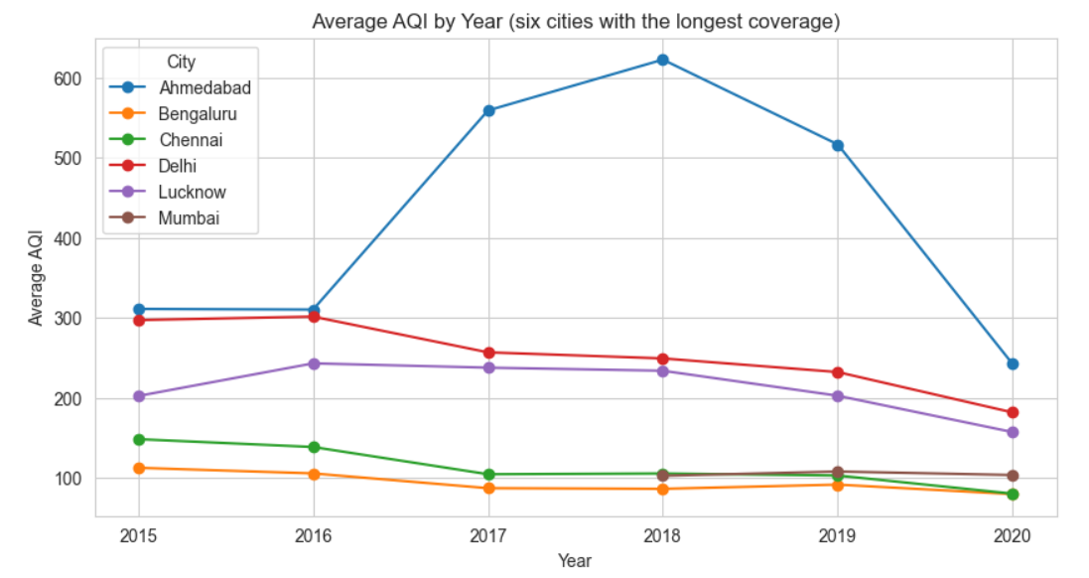

Observation: AQI falls over the years in Delhi (297.0 in 2015 to 181.7 in 2020), Lucknow, Bengaluru and Chennai. Ahmedabad rises sharply during 2017-2019 (peak 622.3 in 2018) and then falls. Mumbai's AQI data starts only in 2018, and 2020 covers only January to July.

6.6 Monthly pattern (Line chart)
monthly = df.groupby('Month')['AQI'].mean()
monthly.plot(marker='o', color='purple', xticks=range(1, 13))
plt.title('Average AQI by Month')
plt.xlabel('Month')
plt.ylabel('Average AQI')
plt.show()

Output:
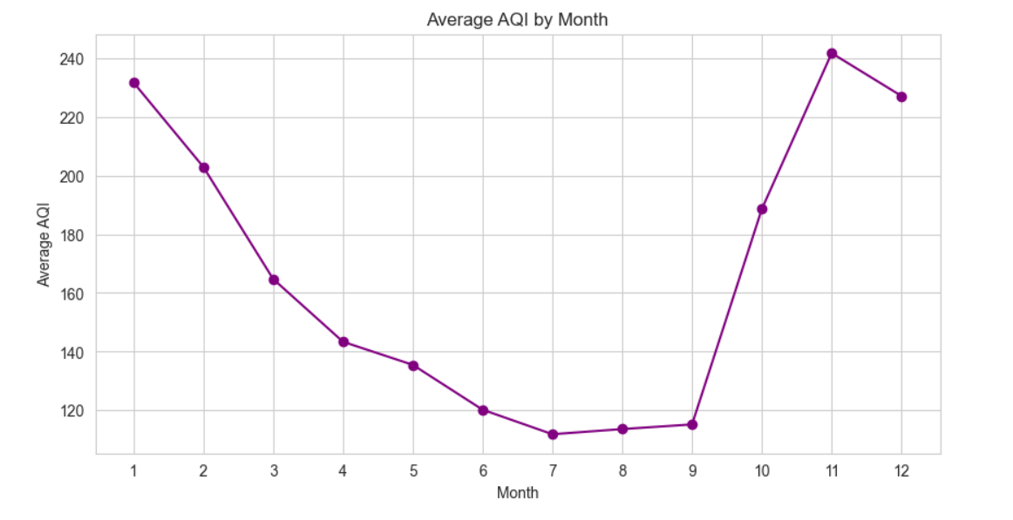

Observation: AQI is highest in November (241.7), followed by January (231.7) and December (227.1), and lowest in July (111.9).
6.7 AQI by season
season_order = ['Winter', 'Summer', 'Monsoon', 'Post-Monsoon']
season_aqi = df.groupby('Season')['AQI'].mean().reindex(season_order)
print(season_aqi.round(1))
season_aqi.plot(kind='bar', color=['steelblue', 'orange', 'green', 'brown'])
plt.title('Average AQI by Season')
plt.ylabel('Average AQI')
plt.xticks(rotation=0)
plt.show()

Output:
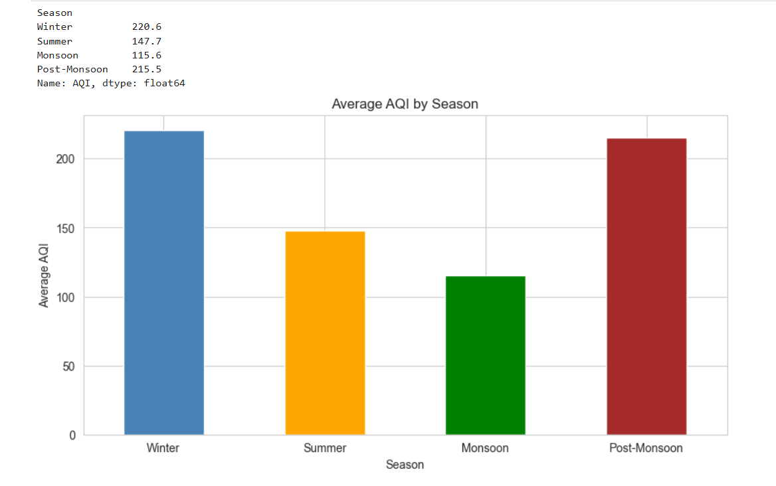

Observation: Winter (220.6) and post-monsoon (215.5) are the worst seasons, while monsoon (115.6) is the cleanest, most likely because rain washes pollutants out of the air.

6.8 AQI spread across the most polluted cities (Box plot)
top10 = city_aqi.head(10).index.tolist()
plt.figure(figsize=(12, 5))
sns.boxplot(data=df[df['City'].isin(top10)], x='City', y='AQI', order=top10)
plt.title('AQI Distribution in the 10 Most Polluted Cities')
plt.xticks(rotation=45)
plt.tight_layout()
plt.show()

Output:
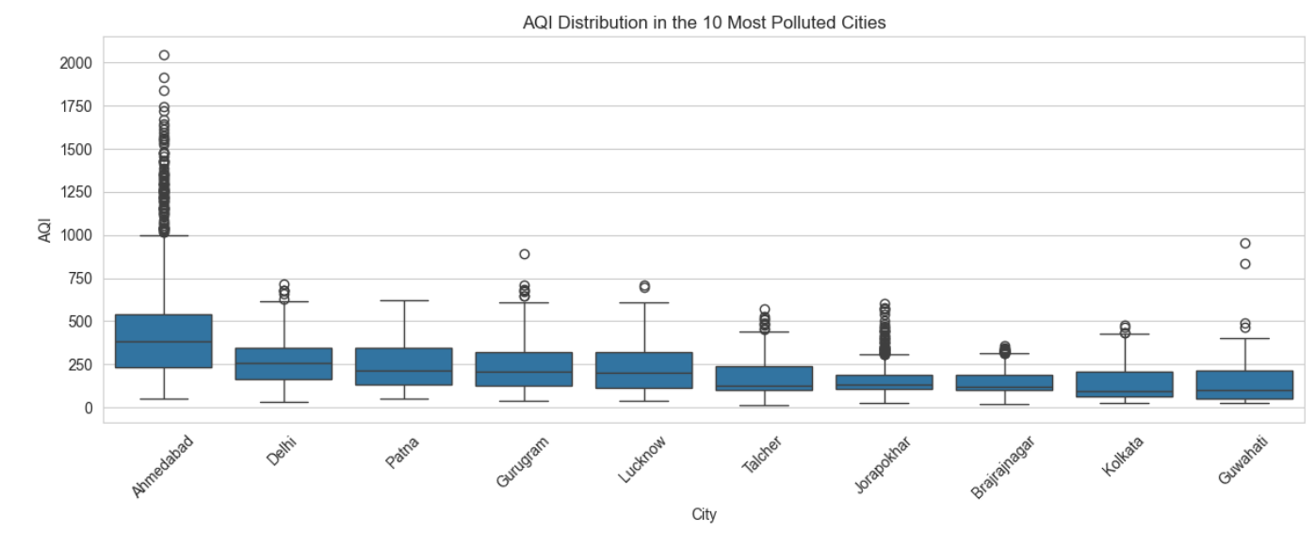
6.9 Relationship between pollutants and AQI (Scatter plots)
sample = df.sample(5000, random_state=42)
fig, axes = plt.subplots(1, 2, figsize=(14, 5))
sns.scatterplot(data=sample, x='PM10', y='AQI', alpha=0.4, ax=axes[0])
axes[0].set_title('PM10 vs AQI')
sns.scatterplot(data=sample, x='PM2.5', y='AQI', alpha=0.4, color='orange', ax=axes[1])
axes[1].set_title('PM2.5 vs AQI')
plt.tight_layout()
plt.show()

Output:
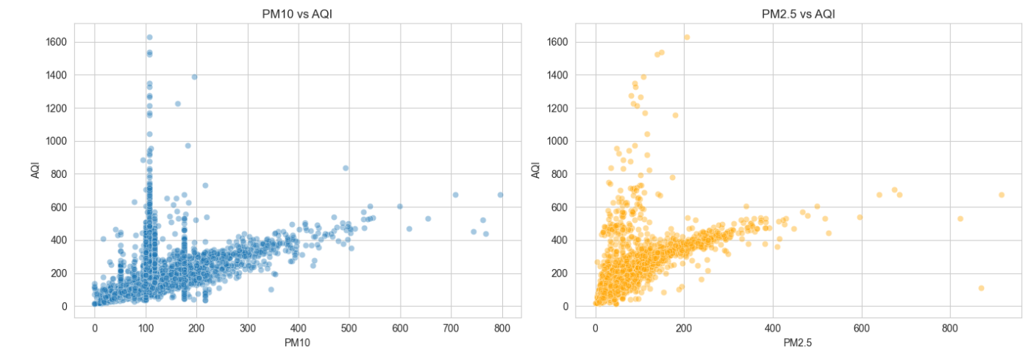

Observation: AQI increases with both PM10 and PM2.5. The vertical stripe near PM10 = 100 is mostly caused by filling missing PM10 values with the city median, so those points are not real readings.

6.10 Correlation analysis (Heatmap)
corr = df[pollutants + ['AQI']].corr()
plt.figure(figsize=(11, 8))
sns.heatmap(corr, annot=True, fmt='.2f', cmap='coolwarm', center=0)
plt.title('Correlation Between Pollutants and AQI')
plt.show()
print(corr['AQI'].sort_values(ascending=False).round(2))
print('NumPy check, PM10 vs AQI:', round(np.corrcoef(df['PM10'], df['AQI'])[0, 1], 2))

Output:
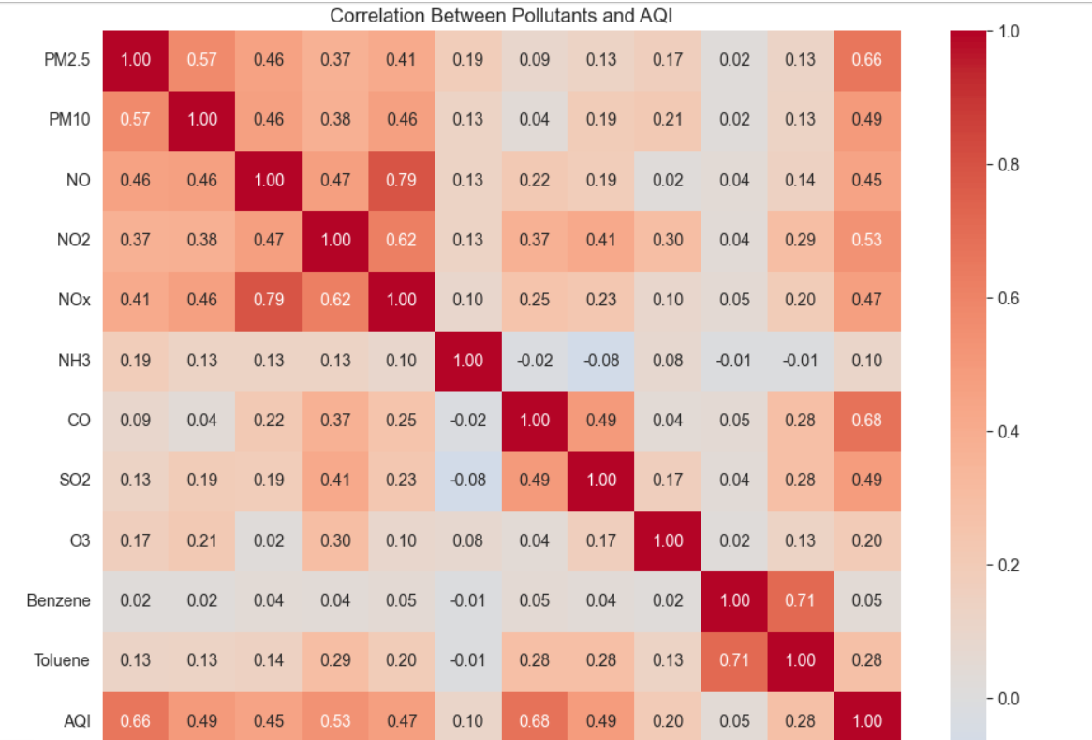
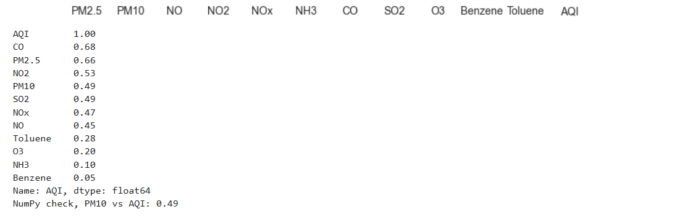

Observation: CO (0.68) and PM2.5 (0.66) have the strongest correlation with AQI, followed by NO2 (0.53). PM10 shows 0.49 here because 38% of its values were filled with the median, which weakens the correlation. On real readings only (before filling), the PM10 correlation was 0.80.

6.11 Effect of the 2020 lockdown (March-June, 2019 vs 2020)
The same four months of the two years are compared for the six cities with full data, so that the comparison is fair and not affected by seasons.
lock = df[df['City'].isin(core) & df['Month'].isin([3, 4, 5, 6]) & df['Year'].isin([2019, 2020])]
comp = lock.groupby(['City', 'Year'])['AQI'].mean().unstack()
print(comp.round(1))
print()
print('Change in AQI (%), 2020 vs 2019:')
print(((comp[2020] - comp[2019]) / comp[2019] * 100).round(1))
comp.plot(kind='bar', figsize=(10, 5))
plt.title('Average AQI, March-June: 2019 vs 2020')
plt.ylabel('Average AQI')
plt.xticks(rotation=45)
plt.tight_layout()
plt.show()

Output:
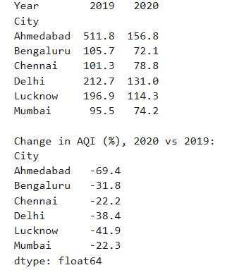
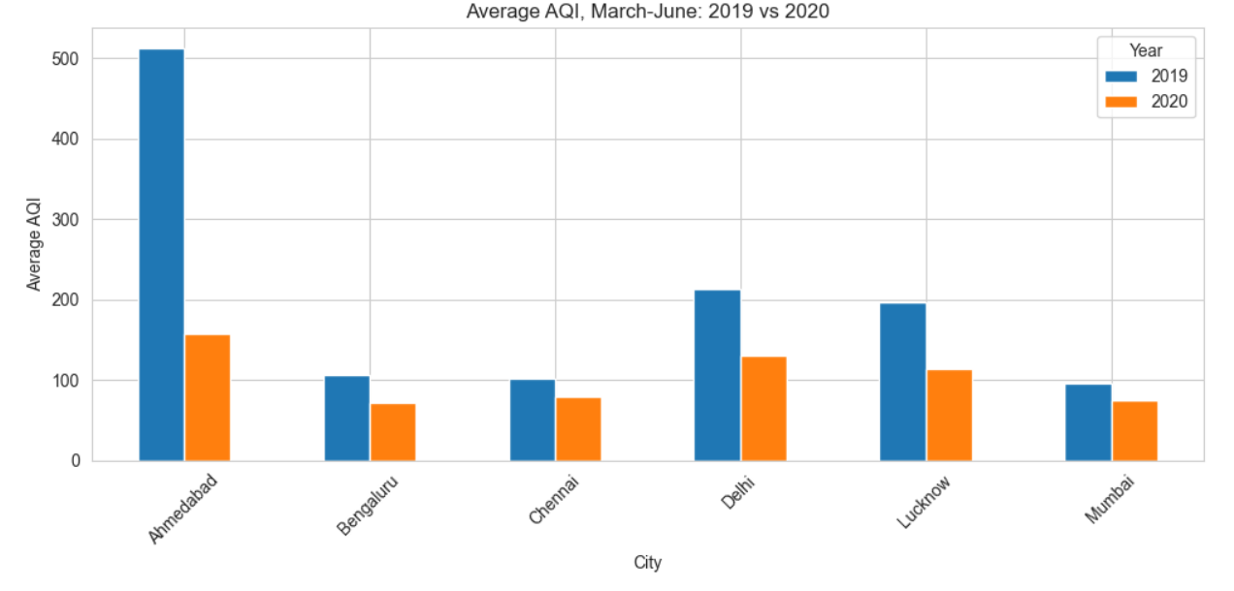

Observation: All six cities had lower AQI in March-June 2020 than in 2019: Lucknow -41.9%, Delhi -38.4%, Bengaluru -31.8%, Mumbai -22.3% and Chennai -22.2%. Ahmedabad shows -69.4%, but this is inflated by its unusually high 2019 values.

7. Key Findings

No. | Finding | Evidence from output
1 | Most polluted city | Ahmedabad: average AQI 452.1 (Delhi 259.5, Patna 240.8)
2 | Least polluted city | Aizawl 34.8 and Shillong 53.8 (short data, not fully comparable)
3 | Worst season and month | November 241.7 (worst month), July 111.9 (best); Winter 220.6 vs Monsoon 115.6
4 | Pollutant most linked to AQI | CO 0.68, PM2.5 0.66, NO2 0.53 (PM10 0.49 after filling, 0.80 on real readings)
5 | Change in AQI during lockdown | AQI dropped 22% to 42% in five cities (Lucknow -41.9%, Delhi -38.4%) in March-June 2020 vs 2019
6 | Share of days in Poor, Very Poor or Severe categories
  26.0% of days in Poor,
  Very Poor or Severe
7 | Distribution is right-skewed with extreme outliers | Mean 166.46 vs median 118.0, skewness 3.40, 1,358 AQI outliers, max 2,049

8. Conclusion
The analysis of CPCB air-quality data shows large differences in pollution between Indian cities, seasons and years. Ahmedabad, Delhi, Patna, Gurugram and Lucknow have the highest average AQI, and pollution is worst in winter and post-monsoon, peaking in November. CO, PM2.5 and NO2 have the strongest link with AQI, and PM10 is also strongly linked on real readings. The AQI distribution is right-skewed, with extreme pollution days. In March-June 2020, AQI was lower than in 2019 in all six cities with full data, by 22% to 42% in five of them (Ahmedabad fell by 69%, which is likely inflated by its unusual data), which suggests that lower traffic and industrial activity during the lockdown improved air quality.
9. Recommendations
- Focus on the main pollutants. PM2.5, CO and NO2 have the strongest link with AQI, so control measures should target vehicle emissions, industrial emissions, dust control at construction sites and crop-residue burning.
- Prepare for the worst season. Cities with high winter AQI should plan early warnings, traffic and construction restrictions, and health advisories before the season starts.
- Target the most polluted cities. Resources and monitoring should be concentrated on the cities with the highest average AQI and the most Poor, Very Poor and Severe days.
- Improve monitoring. Many readings are missing, so more working monitoring stations and better data quality would make future analysis more reliable.
- Learn from the lockdown. Policies that reduce vehicle and industrial emissions can lower AQI, so long-term measures such as public transport and electric vehicles should be supported.

10. Limitations
- The yearly trend uses six cities with the longest coverage; Mumbai's AQI data starts only in 2018.
- 2020 data ends on 1 July 2020, so 2020 is not a full year.
- Missing pollutant values were filled with city-wise medians, which is an estimate and not a real measurement.
- The Xylene column was removed because of too many missing values.
- The lockdown comparison shows association and does not prove that the lockdown alone caused the change, because weather also affects pollution.
- Ahmedabad's AQI contains many values above 500 (up to 2,049), outside the official AQI scale, so its high average may reflect data errors.
- Filling 38% of missing PM10 values with the median weakens its correlation with AQI and creates a visible vertical stripe in the scatter plot.
- such as Aizawl, Kochi and Ernakulam have only a few months of data, so their averages are not comparable.

11. References
- Central Pollution Control Board (CPCB), Government of India: https://cpcb.nic.in
- Kaggle: Air Quality Data in India (2015-2020) by rohanrao

